Mark,
That is exciting news about the former State Theatre having a new lease on life. C&V Investments (Paul Chieng and Kevin Vien) saw a lot of potential in the theatre along with their own passion for theatre. They made a large investment in our downtown. The re-opening of the theatre will play a role in bringing our downtown back and ties into the recent presentation of the South Coast Rail Advisory Committee to the Board of Selectmen on August 3rd. The conceptual plan presented can be implemented right now, without the South Coast Rail extension to New Bedford and Fall River.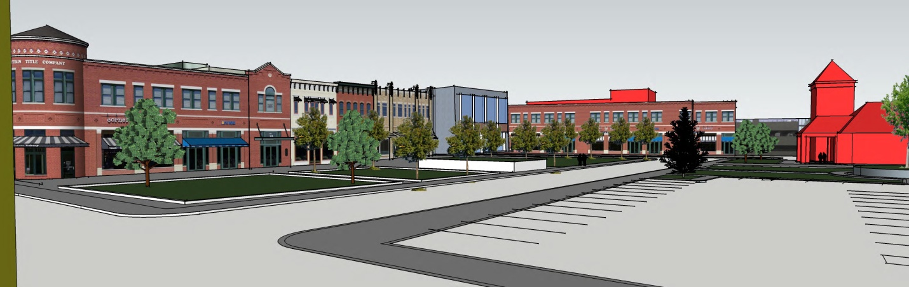
Rose Street Extension: James Barron and South Coast Rail Advisory Committee
I met Paul and Kevin while they were at the Building Department with the former owner just after being elected to the Board of Selectmen. They took me through the theatre back in April and we discussed their plans and what would be needed to re-open the theatre. It was from there we started discussions with Star’s theatre group. Meetings were held with the Town Planner Joe Laydon, Paul, Kevin, Mike and myself. There are historical grants available, possible use of CPC funds for facade work and offers of assistance by Congressman Lynch’s office. Congressman Lynch has had preliminary discussion with town officials about the possible relocation of the distribution portion of the post office and leaving a store front in the downtown. The above drawing shows one possibility of how redevelopment of the Post Office site may look in the future. I am very optimistic we can make positive changes to our downtown that will bring new investment, but it is not going to happen overnight and it will not happen on its own. The South Coast Rail Advisory Committee has given us a starting point and the Selectmen supported the advisory committee’s ideas. John J. Stagnone Board of Selectmen, South Coast Rail Advisory Committee

